How to install ASR1-Belice plugin

Preliminary operations:

- Download and install the qgis software updated to version 3.16
https://www.qgis.org/en/site/forusers/download.html

- Download the plugin from the beliceproject site in the download area
https://www.beliceproject.eu/download-area/

Before proceeding with the installation of the ASR1-Belice plugin it is necessary to install the quickosm plugin in the following way:

From the qgis home screen open the window Plugins and then Manage and install Plugins

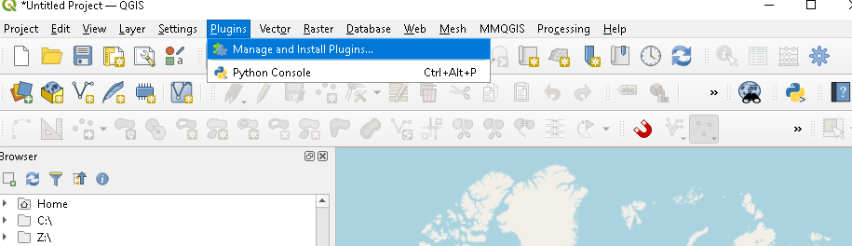
A plugins management window will open

In the left part go to all
in the search bar write quickosm
Once found select quickosm (make it blue) and finally at the bottom right install plugin
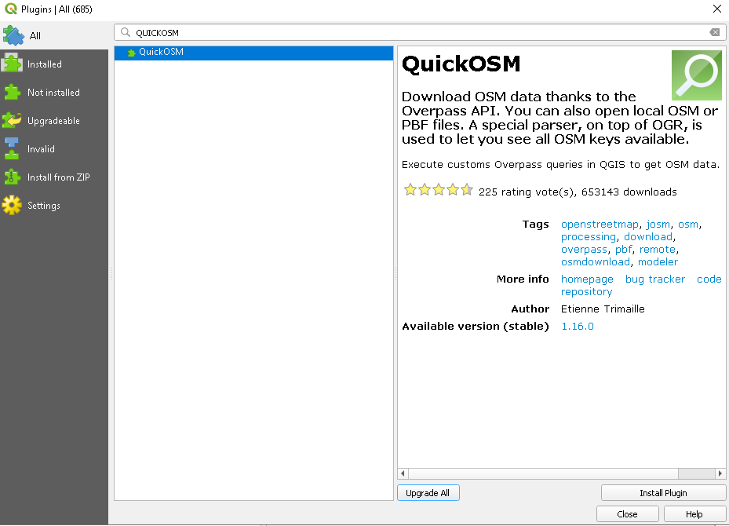

Always from the same window press install from zip on the right.

It is necessary at this point to give the paths of the file asr_1_belice.zip and press install plugin

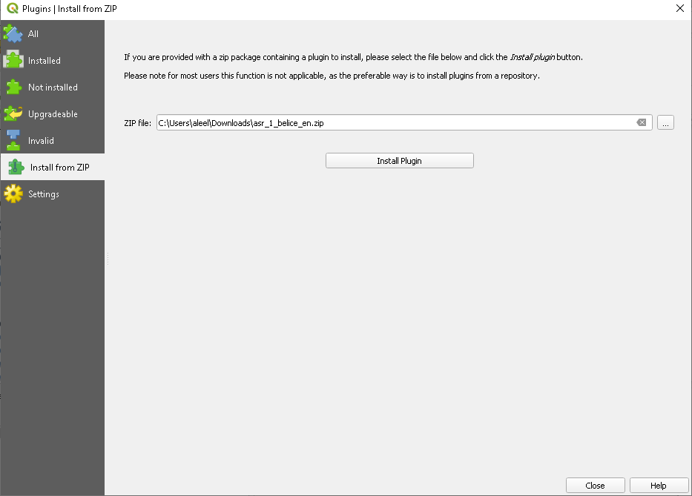

The tools of the new plugin we find them by opening processing at the top and then toolbox
